Lesson 4 plan: Formatting, graphs and charts
About the lesson
This lesson is concerned with formatting cells to improve the presentation of data in a spreadsheet, using conditional formatting to help identify trends and creating graphs and charts using the data. Students will learn how to format cells and how to apply conditional formatting based on a set of rules. They will apply this learning to practical activities using the spreadsheets provided. They will then learn about three common types of chart and their use, and practise creating charts using data provided.
Learning objectives
By the end of this lesson, students will
- know about different types of formatting.
- be able to apply formatting to individual cells.
- be able to apply conditional formatting to a range of cells.
- understand the differences between bar charts, pie charts and line graphs.
- be able to create graphs and charts in spreadsheets based on data provided.
National Curriculum
The following subject content from the KS3 National Curriculum is included in this lesson:
- Design, use and evaluate computational abstractions that model the state and behaviour of real-world problems and physical systems.
- Understand the hardware and software components that make up computer systems.
Links
Creating graphs and charts from the data in a spreadsheet is one of its most frequent uses in other subjects. There are direct links with maths and the sciences when considering the different types of chart and graph and their uses.
Key terminology
formatting, conditional formatting, bar chart, column chart, pie chart, line graph
Teaching and learning activities
Share the objectives for the lesson with students (Slide 2 of Lesson 4 presentation).
Starter
Show students an image of unformatted data in a spreadsheet (Slide 3).
Ask: How could the presentation of this data be improved?
The headings for each column could be made easier to see. The prices should be formatted with a £ sign.
Show students image of the same data with formatting (Slide 4).
Ask: Can you identify ways in which this data has been formatted?
Larger text size for column headings, different colour for column headings, aligning the text in some cells differently, use of background fill, cost column formatted as currency, borders added.
Part 1
Demonstrate how to apply formatting to individual cells (Slide 5 and page 24 of the Student Book, plus Video 4.1).
Ask students to complete Activity 4.1: Formatting practice (Slide 6, Excel workbook 4, sheet 1/Excel workbook 4.1; Google Sheets workbook 4, sheet 1/Google Sheets workbook 4.1).
Answer
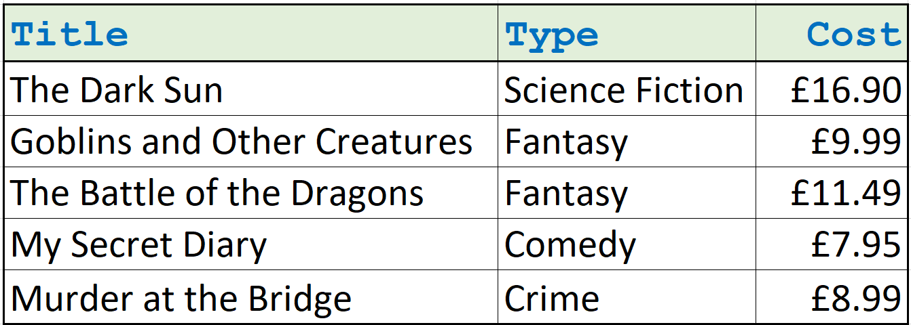
- Make sure that students access the cell formatting options correctly, from the ribbon on the Home tab or by right clicking on the cell or cells they want to format and selecting Format cells from the drop-down list.
- Note that some formatting can be edited directly from the ribbon on the Home tab of the worksheet.
Part 2
Explain conditional formatting and demonstrate how to apply conditional formatting to cells on a spreadsheet (Slide 7 and page 24 of the Student Book, plus Video 4.2).
Ask students to complete:
Activity 4.2: Picture 1 (Slide 8, Excel workbook 4, sheet 2/Excel workbook 4.2; Google Sheets workbook 4, sheet 2/Google Sheets workbook 4.2)
Common misconceptions
Some students may think that they need to apply conditional formatting separately to every cell. Remind them that conditional formatting can be applied to all the cells at the same time, by selecting them before adding the formatting rule.
Answer
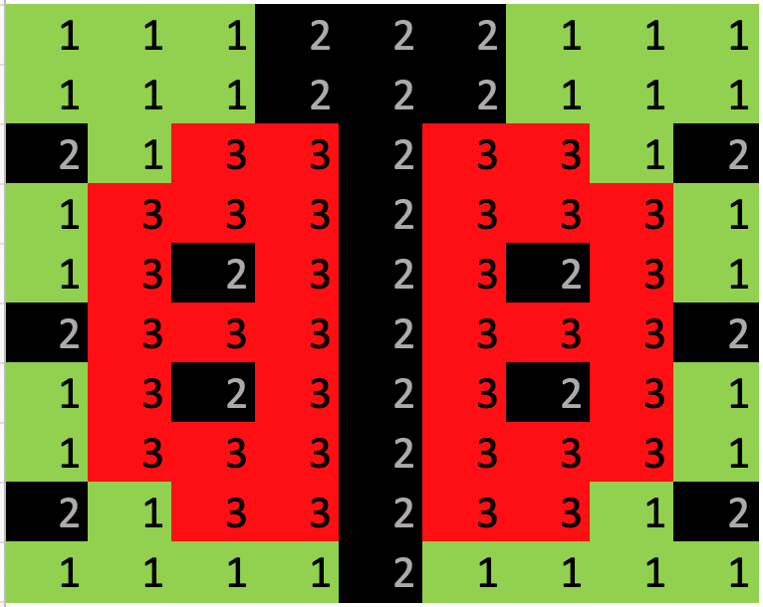
Ask students to complete Activity 4.3: Picture 2 (Slide 8, Excel workbook 4, sheet 3/Excel workbook 4.3; Google Sheets workbook 4, sheet 3/Google Sheets workbook 4.3)
Answer
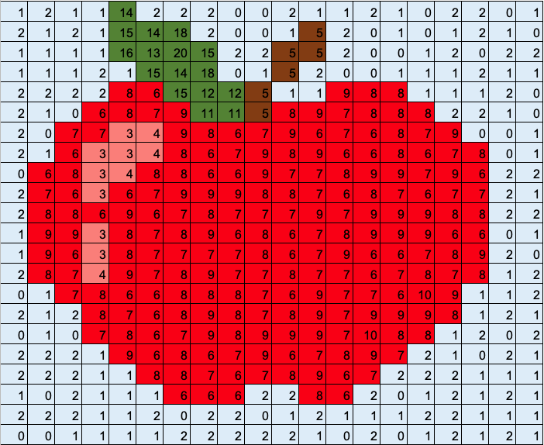
Activity 4.4: Picture 3 (Slide 8, Excel workbook 4, sheet 4/Excel workbook 4.4; Google Sheets workbook 4, sheet 4/Google Sheets workbook 4.4).

Answer

- Make sure students always highlight the whole picture area before applying any conditional formatting.
- Check that the correct rules have been applied, for example, ‘Between’ and that the correct numbers have been referenced.
- Note that formatting rules can be edited by highlighting the cells and then selecting Manage Rules from the conditional formatting icon.
Part 3
Share the information about graphs and charts (Slide 9 and page 25 of the Student Book).
Ask: What different types of graph or chart can you name and describe?
Explain the use of bar charts and column charts (Slides 10–11 and page 25 of the Student Book, plus Video 4.3).
Ask students to complete Activity 4.5: Temperature (Slide 12, Excel workbook 4, sheet 5/Excel workbook 4.5; Google Sheets workbook 4, sheet 5/Google Sheets workbook 4.5)

Example answer
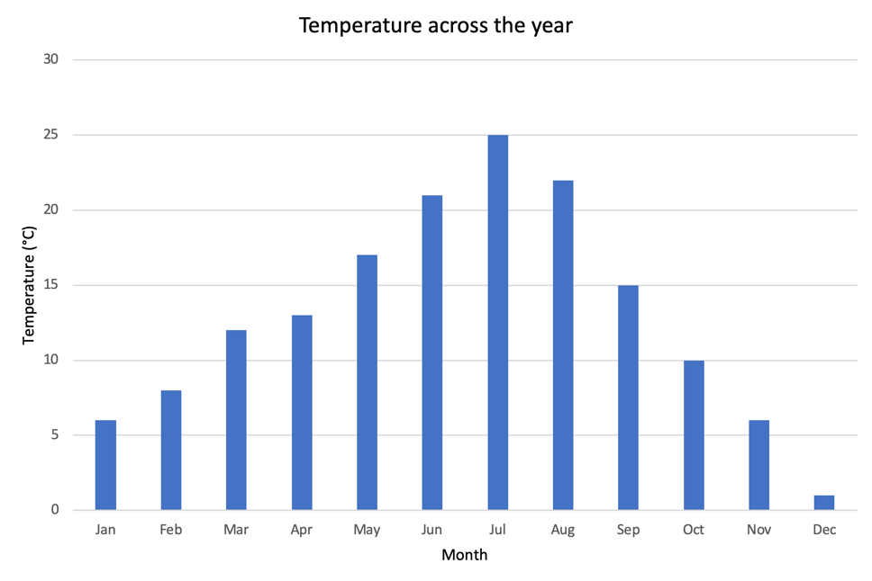
- Make sure that all the data, including the column headings, is selected before trying to insert the chart. Check that the correct type of chart is selected.
- Check that the title of the chart has been edited by clicking over the text and then typing an appropriate title.
- Makes sure that the x and y axes have suitable labels.
- Remind students to double click on the chart to bring up the formatting options in order to add labels or make other adjustments to the layout.
Part 4
Explain the use of pie charts (Slide 13 and page 25 of the Student Book, plus Video 4.4).
Ask students to complete Activity 4.6: Travel (Slide 14, Excel workbook 4, sheet 6/Excel workbook 4.6; Google Sheets workbook 4, sheet 6/Google Sheets workbook 4.6).

Example answer
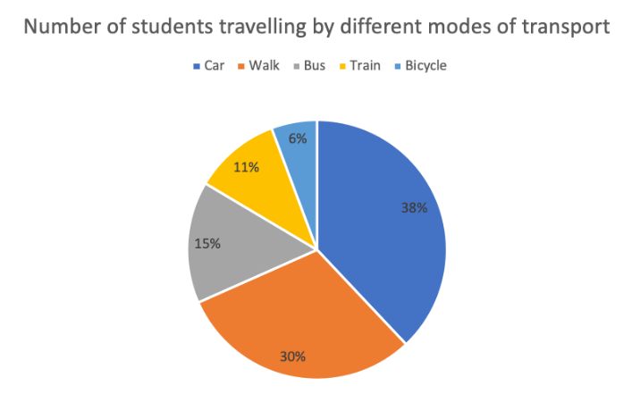
- Make sure that all the data, including the column headings, is selected before trying to insert the chart.
- Check that the correct type of chart is being selected.
- Check that the title of the chart has been edited by clicking over the text and then typing an appropriate title.
- Makes sure that the % value of each segment has been included. These can be added by clicking on the Quick Layout button.
Part 5
Explain the use of line graphs (Slide 15 and page 25 of the Student Book, plus Video 4.5).
Ask students to complete Activity 4.7: Height (Slide 16, Excel workbook 4, sheet 7/Excel workbook 4.7; Google Sheets workbook 4, sheet 7/Google Sheets workbook 4.7).
Example answer
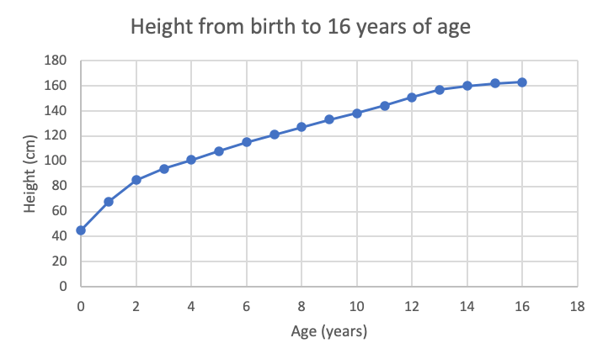
- Make sure that all of the data, including the column headings is selected before trying to insert the chart.
- Check that the correct type of chart is being selected.
- Check that the title of the chart has been edited by clicking over the text and then typing an appropriate title.
- Makes sure that the x and y axes have suitable labels.
- Remind students to double click on the chart to bring up the formatting options in order to add labels or make other adjustments to the layout.
Plenary
Check students’ knowledge and understanding with a short questions and answer session linked to the learning objectives.
- Identify three ways in which the appearance of a cell could be formatted. (Example answer: Change the size of font, change the text colour, add a background fill.)
- When might we use conditional formatting? (Example answer: We could use conditional formatting when we want to quickly see which students have scored more than the pass mark and which students have scored less than the pass mark.)
- What chart should we use to show the percentage of students in the class who own a pet? (Answer: A pie chart)
- What sort of chart is most likely to be used to plot the results of a science experiment? (Answer: A line graph)
Homework
Ask students to complete any activities they did not finish during the lesson.
Ask students to complete Quiz 4.
Stretch activities
Students who complete the activities in this lesson quickly could be encouraged to find out about a wider range of the graphs and charts available in spreadsheet applications. Then find out when it would be suitable to use the different graph/chart types that they discover. Students could also experiment with applying different formatting to the chart or graph produced to try to enhance its visual effect.
Support activities
Some students may need guiding towards the correct conditions to use when writing their conditional formatting rules. Remind them about the logical operators and make sure that they understand the difference between greater than > and less than <.
If students are confused about which type of chart or graph to use, demonstrate the differences between the outputs by selecting a range of data and changing the chart type several times. Encourage them to identify which chart shows the meaning or trends of the data most clearly.
A number of short and informative videos can be found online that demonstrate the use of features in spreadsheets such as: www.youtube.com/c/microsoft365/playlists?view=50&sort=dd&shelf_id=5 for MS Excel, and www.youtube.com/channel/UCco3PQfioWg5uFBxi1ndb2A for Google Sheets.

